

MATHEMATICS
Specialist Units 3 & 4

Test 5 – Applications of Differentiation

Semester 2 2019

Section Two – Calculator Assumed

Time allowed for this section
Working time for this section: 35 minutes
Marks available: 33 marks

Material required/recommended for this section

To be provided by the supervisor
This Question/Answer booklet
Formula sheet

To be provided by the candidate
Standard items: pens, pencils, pencil sharpener, eraser, correction fluid, ruler, highlighters

Special items: drawing instruments, templates, notes on one unfolded sheet of A4 paper, and up to three calculators satisfying the conditions set by the Curriculum Council for this course.

Important note to candidates
No other items may be used in this section of the examination. It is your responsibility to ensure that you do not have any unauthorised notes or other items of a non-personal nature in the examination room. If you have any unauthorised material with you, hand it to the supervisor before reading any further.
- (5 marks: 3, 2)
After $t$ seconds, the displacement $x$ centimetres of a small mass attached to a spring, oscillates about a fixed point $O$ according to the differential equation $\frac{d^{2}x}{dt^{2}}=-25x cms^{-2}$.
The initial velocity is 15 centimetres per second and the initial displacement is zero.

- Determine the function $x(t)$ that gives the displacement of the mass at time $t$ .

- Calculate the distance the mass travels during the first 3 seconds.

- (5 marks: 2, 3)
A dog’s drinking bowl is formed by revolving the curve $y=\frac{1}{10}x^{2}$, $0≤x≤10$, through 360$°$ about the y-axis. The units of $x$ and $y$ are in centimetres.

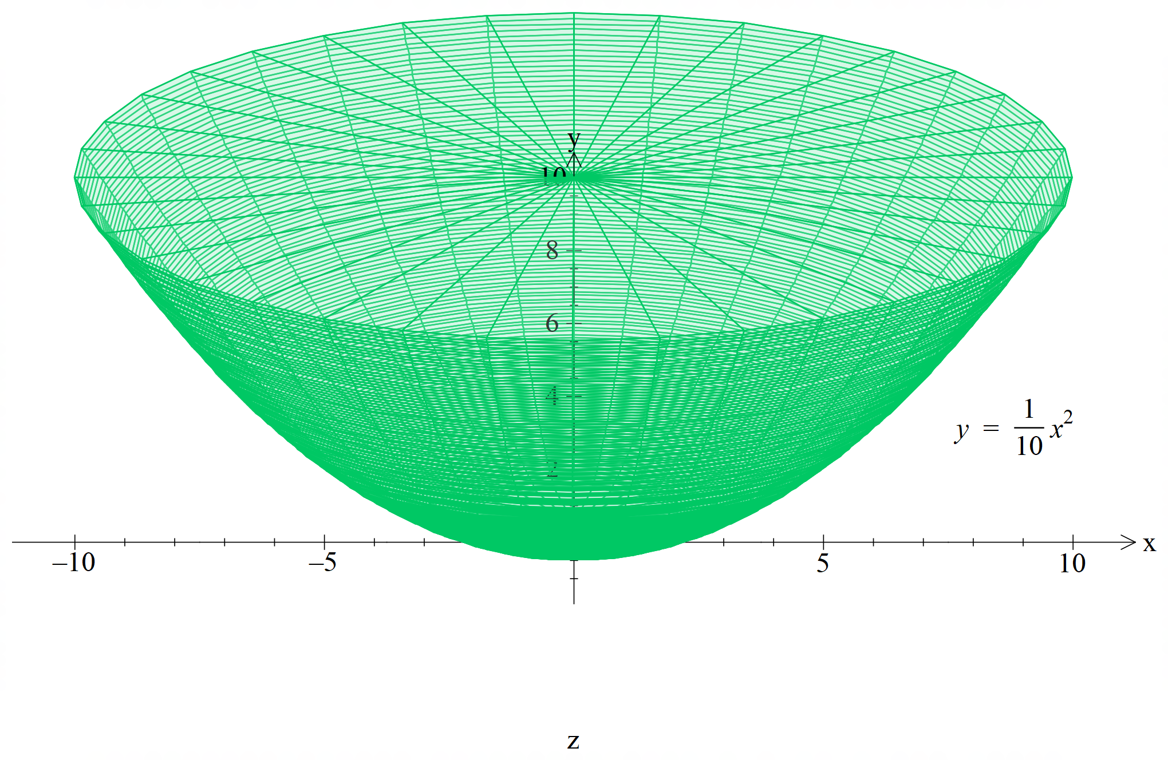

- Show the expression connecting the height $h$ of water in the bowl and the volume $V$ of water in the bowl is given by $V=5πh^{2}$.

- The bowl is filled with water at a rate of 50mL per second. At what rate is the height of the water increasing at the time when the bowl contains 600 mL of water?

- (7 marks)
Determine the values of the constants $a$ and $b$ if $y=e^{4x}(2x+1)$ is a solution of the differential equation $\frac{d^{2}y}{dx^{2}}-a \frac{dy}{dx}+by=0$

- (10 marks: 6, 4)
An ecology student is studying the repopulation of wild emus in Western Australia after a drought. She notices that the population growth rate is approximately logistic so that $\frac{dP}{dt}=kP\left(1-\frac{P}{A}\right)$ where $P\left(t\right)$ is the population $t$ years after her study begins.

The carrying capacity $A$ is known to be 2550 emus, since this was the population before the drought.

Initially, the student finds that there are 310 emus. After 2 years she finds there are 390 emus.

- Given that $\frac{1}{P(2550-P)}=\frac{1}{2550}\left(\frac{1}{P}+\frac{1}{2550-P}\right)$ , use the separation of variables technique to determine the equation to find the population $P(t)$ after $t$ years

- Find the time at which the population growth rate is a maximum.

- (6 marks: 3, 3)
The graph of ${\left(x^{2}+y^{4}-2\right)}^{3}=8x^{2}y^{5}$ is shown below:

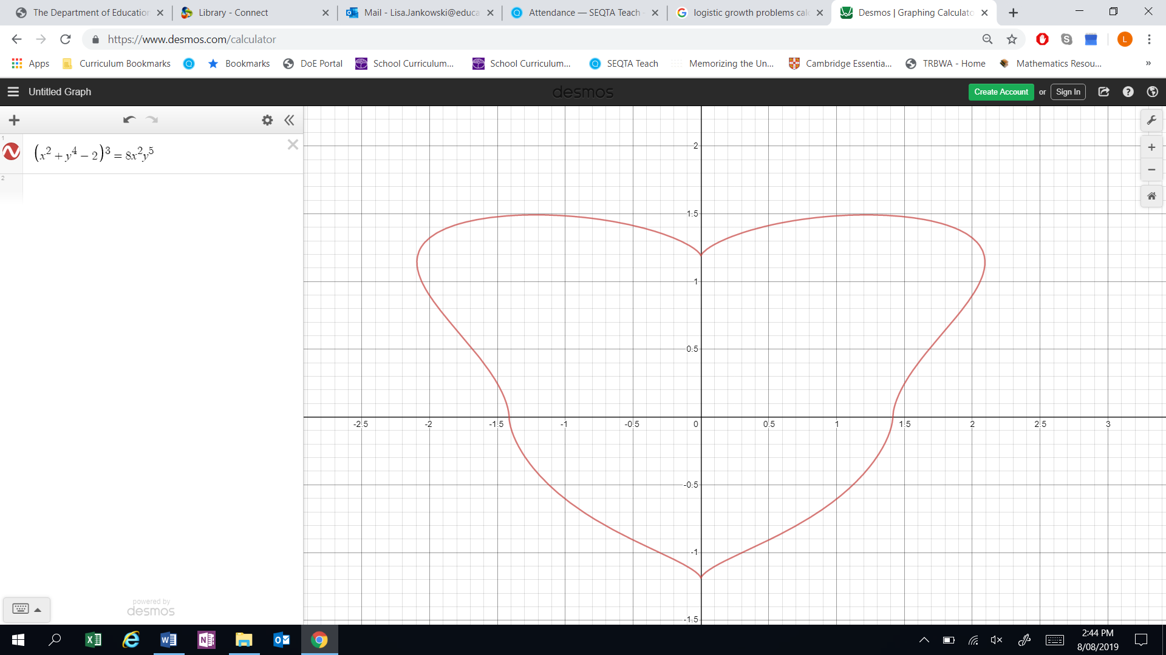

- By implicitly differentiating the given equation, obtain an equation relating $x, y$ and $\frac{dy}{dx}$.
Note: Do not attempt to obtain $\frac{dy}{dx}$ as the subject of this equation.

- Determine the coordinates of the point on the graph in the first quadrant ($x>0 and y>0\}$ where the gradient is horizontal.

End of Test

This page has intentionally been left blank
You may use this space to extend or re-attempt an answer to a question or questions and should you do so then number the question(s) attempted and cross out any previous unwanted working.

